

#### ITS/ESDV Ontario Graduate Certificate

Course: ITC 5402 – Capstone Project

**Configuration Management**

**Database**

Project Manual

**Sagar Sharma (Team Lead)**

**Debashish Mittra**

**Manraj Singh Sandhu**

**Manpreet Kaur Ratol**

**Contents**

Introduction………………………………………………………………………………………………. 3

Configuration Items……………………………………………………………………………………. 3

Operational Support Attributes……………………………………………………………………. 4

Tools Used……………………………………………………………………………………………….. 4

Creating CMDB Database……………………………………………………………………………. 5

Populating Tables……………………………………………………………………………………… 6

Analysis…………………………………………………………………………………………………... 7

Automated Data Insertion………………………………………………………………………….. 8

Generating Reports…………………………………………………………………………………… 9

Progressive Reports and Dashboard………………………………………………………..…… 10

Filtering Data……………………………………………………………………………………………. 13

Reports Mobility……………………………………………………………………………………….. 14

Appendix…………………………………………………………………………………………………. 15

**Configuration Management Database (Inventory)**

1. **INTRODUCTION**

A [**Configuration Management**](https://en.wikipedia.org/wiki/Configuration_Management)**Database** (**CMDB**) is an ITIL (Information technology infrastructure library) [database](https://en.wikipedia.org/wiki/Database) used by an organization to store information about hardware and software assets (commonly referred to as [Configuration Items](https://en.wikipedia.org/wiki/Configuration_item) [CI]). This database acts as a [data warehouse](https://en.wikipedia.org/wiki/Data_warehouse) for the organization and also stores information regarding the relationship between its assets. The CMDB provides a means of understanding the organization's critical assets and their relationships, such as [information systems](https://en.wikipedia.org/wiki/Information_system), upstream sources or dependencies of assets, and the downstream targets of assets.

**2. Configuration Items**

The Configuration Items (CIs) that Humber shall track are as follows:

Physical Attributes:

a. Location

b. Rack

c. Rack Unit

d. Model Number

e. Serial Number

f. Lifecycle Dates

g. Device type

**Service Attributes:**

a. Business criticality (Tiering)

b. Service Level Availability Goal

c. Technical Owner

d. Business Owner

e. Service or Application Name

**3. Operational Support Attributes:**

a. Status

b. Maintenance/Warranty information

c. Maintenance Windows

d. Relationships

e. Technical data (LUNs, clustering, etc.)

**4. TOOLS USED:**

* Microsoft SQL Server Management Studio 2017
* SSRS (SQL Server Reporting Services)
* Report Builder
* Visual Studio 2017
* Power BI

**5. Creating CMDB database**

Through, MS SQL Server Management Studio 2017 we have created a database with table definitions and created relationships according to the data.

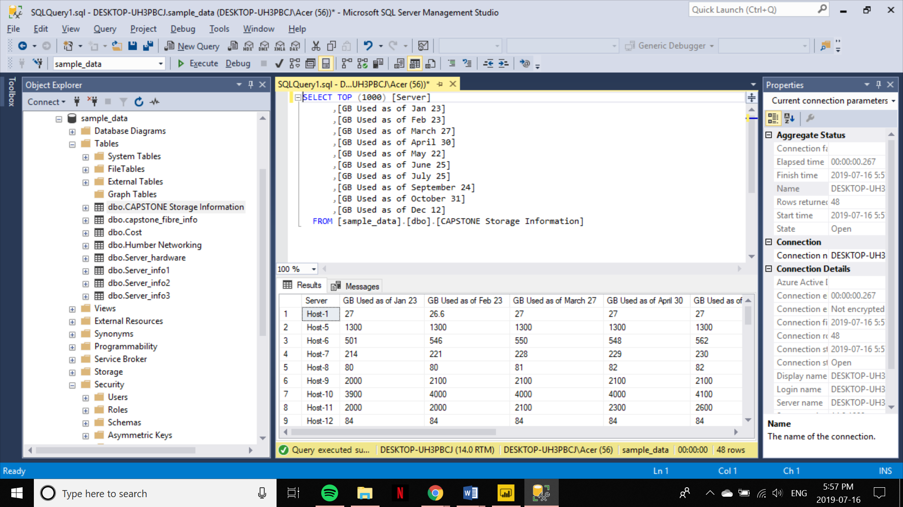

**Populating Tables**

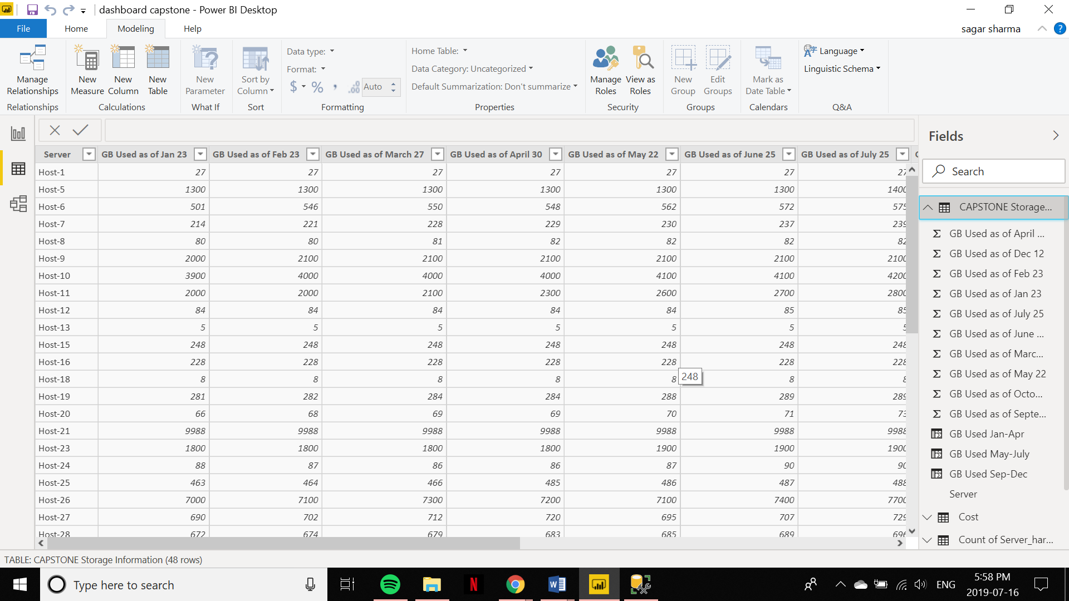

**ANALYSIS: -**

**Database and relationship diagram**

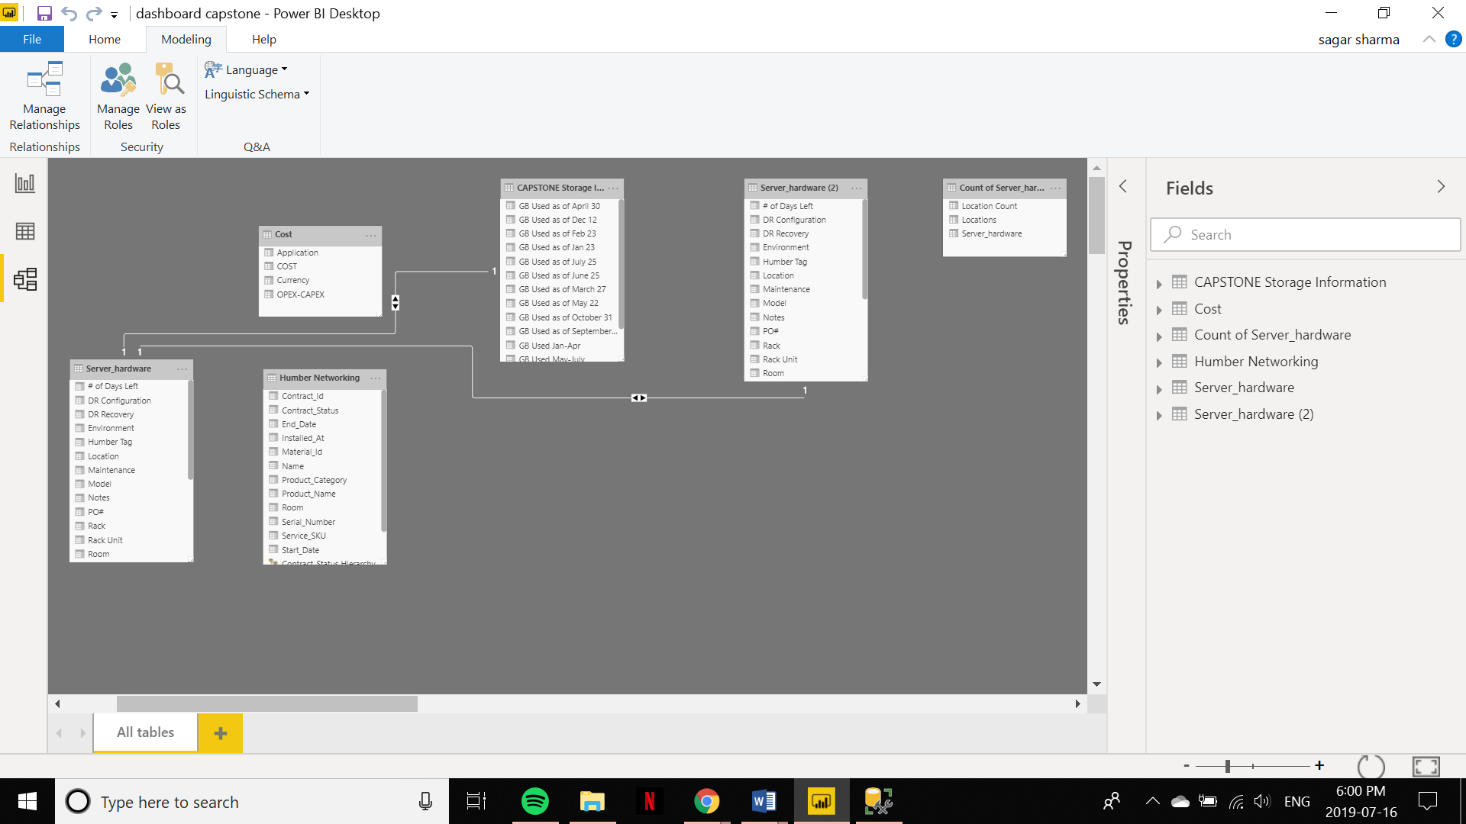

**Automated Data Insertion**

To insert data automatically I created a job in SSIS which inserts data from the raw files automatically at midnight. Whatever, updation that is done throughout the day on raw files will automatically be inserted into the database. I also created a filter on columns which will convert several characters into numeric whichever was needed.

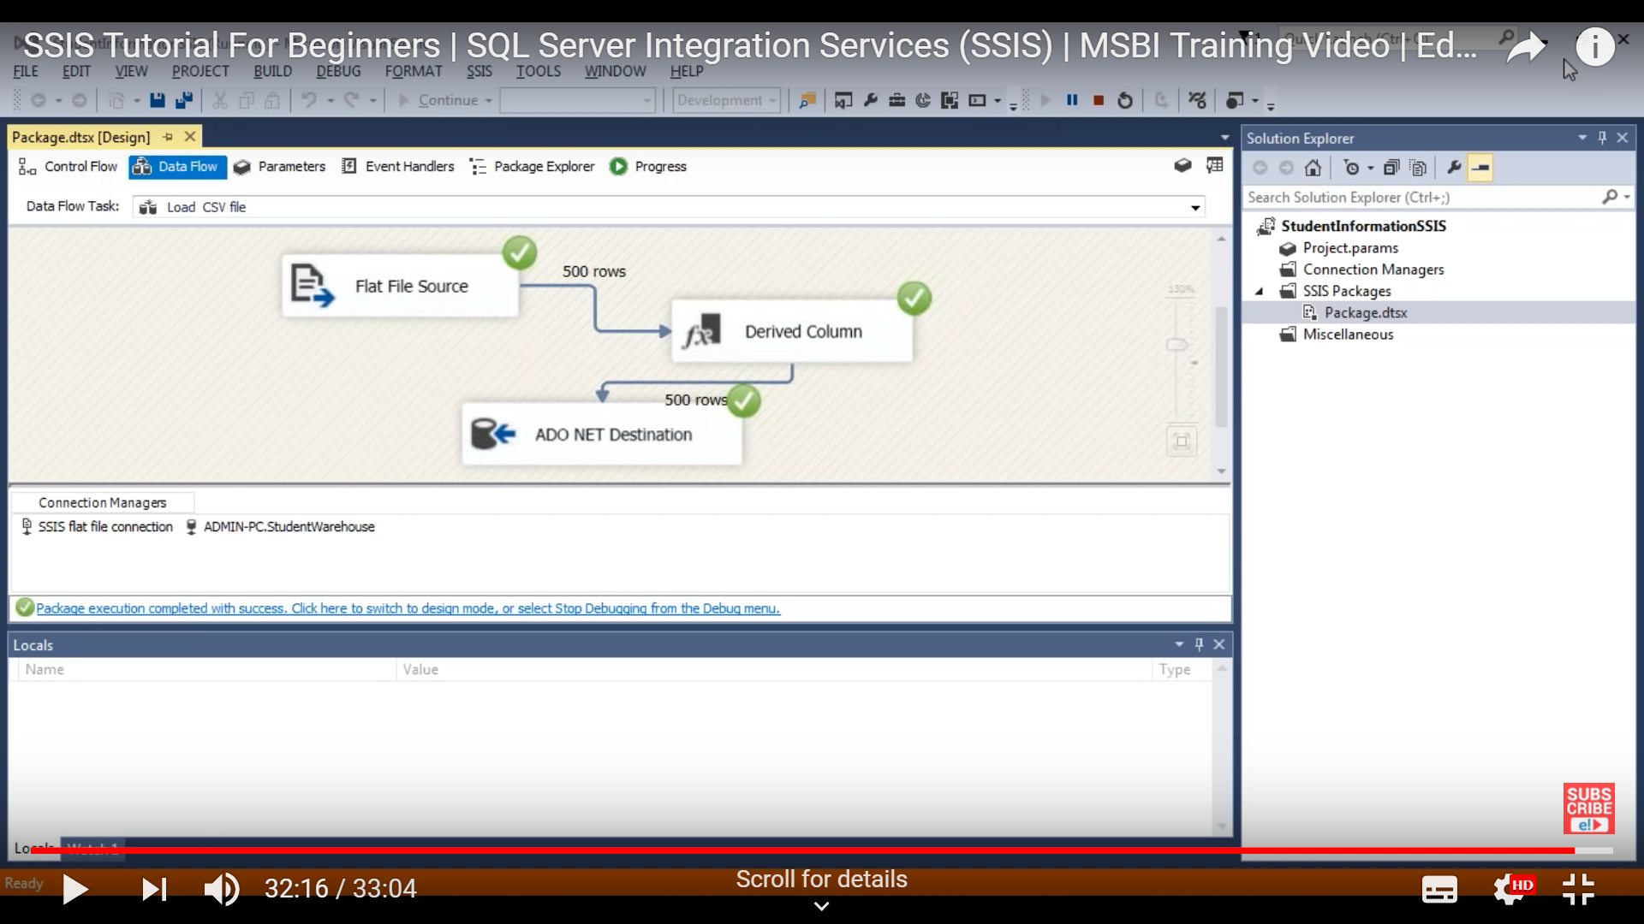

**GENRATING REPORTS**

For the initial phase of the project we created some reports on report builder and visual studio to get an eagle’s vision on where our projects going to be. The reports that we generated were pretty static. The reports were understandable but there was no scope for making them dynamic and appealing. Below are some screenshots of it.

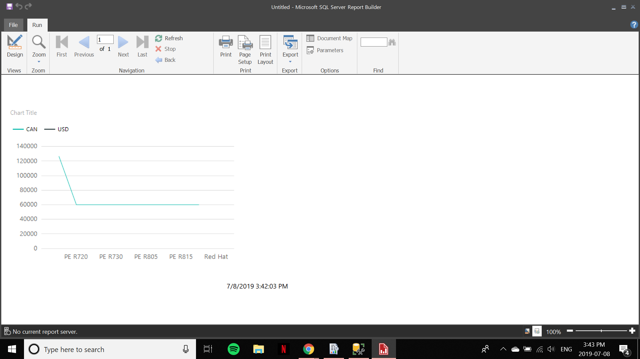

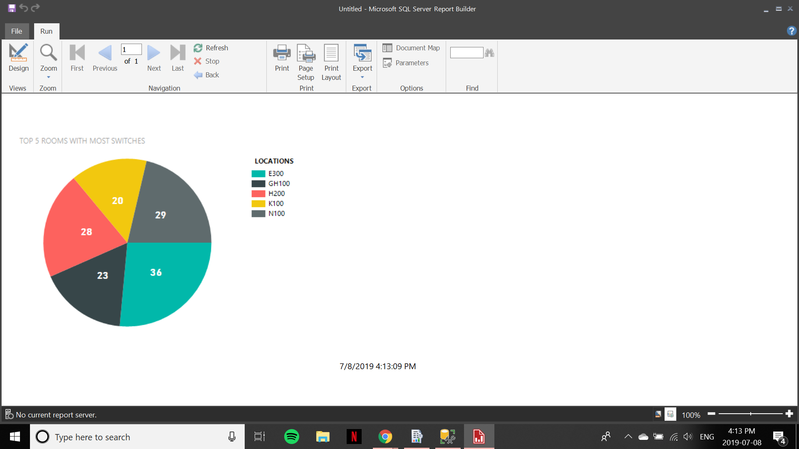

**PROGRESSIVE REPORTS AND DASHBOARD**

As we progressed through the project, we created more dynamic reports and also created dashboard so that the reports are more user-friendly and gives information 100% accurate. We created a 4 page/tab dashboard which are accessible with various buttons, giving user a full comprehensive view of the information. We also have filter in our report through which user can the data of specific device or specific service owner.

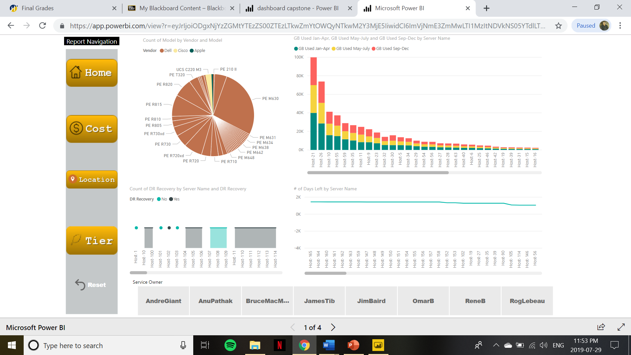

* All the service owners are user clickable. If the user wants to see the data for the owner Bruce MacMillan, just a click on his button is needed.

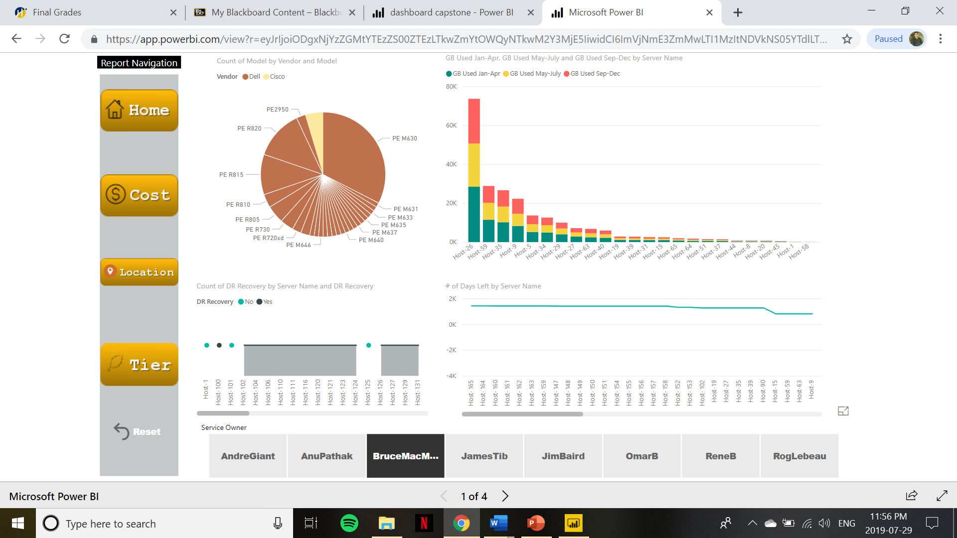

* The next few pages are as follows. By clicking the Cost button user can see info on that specific page.

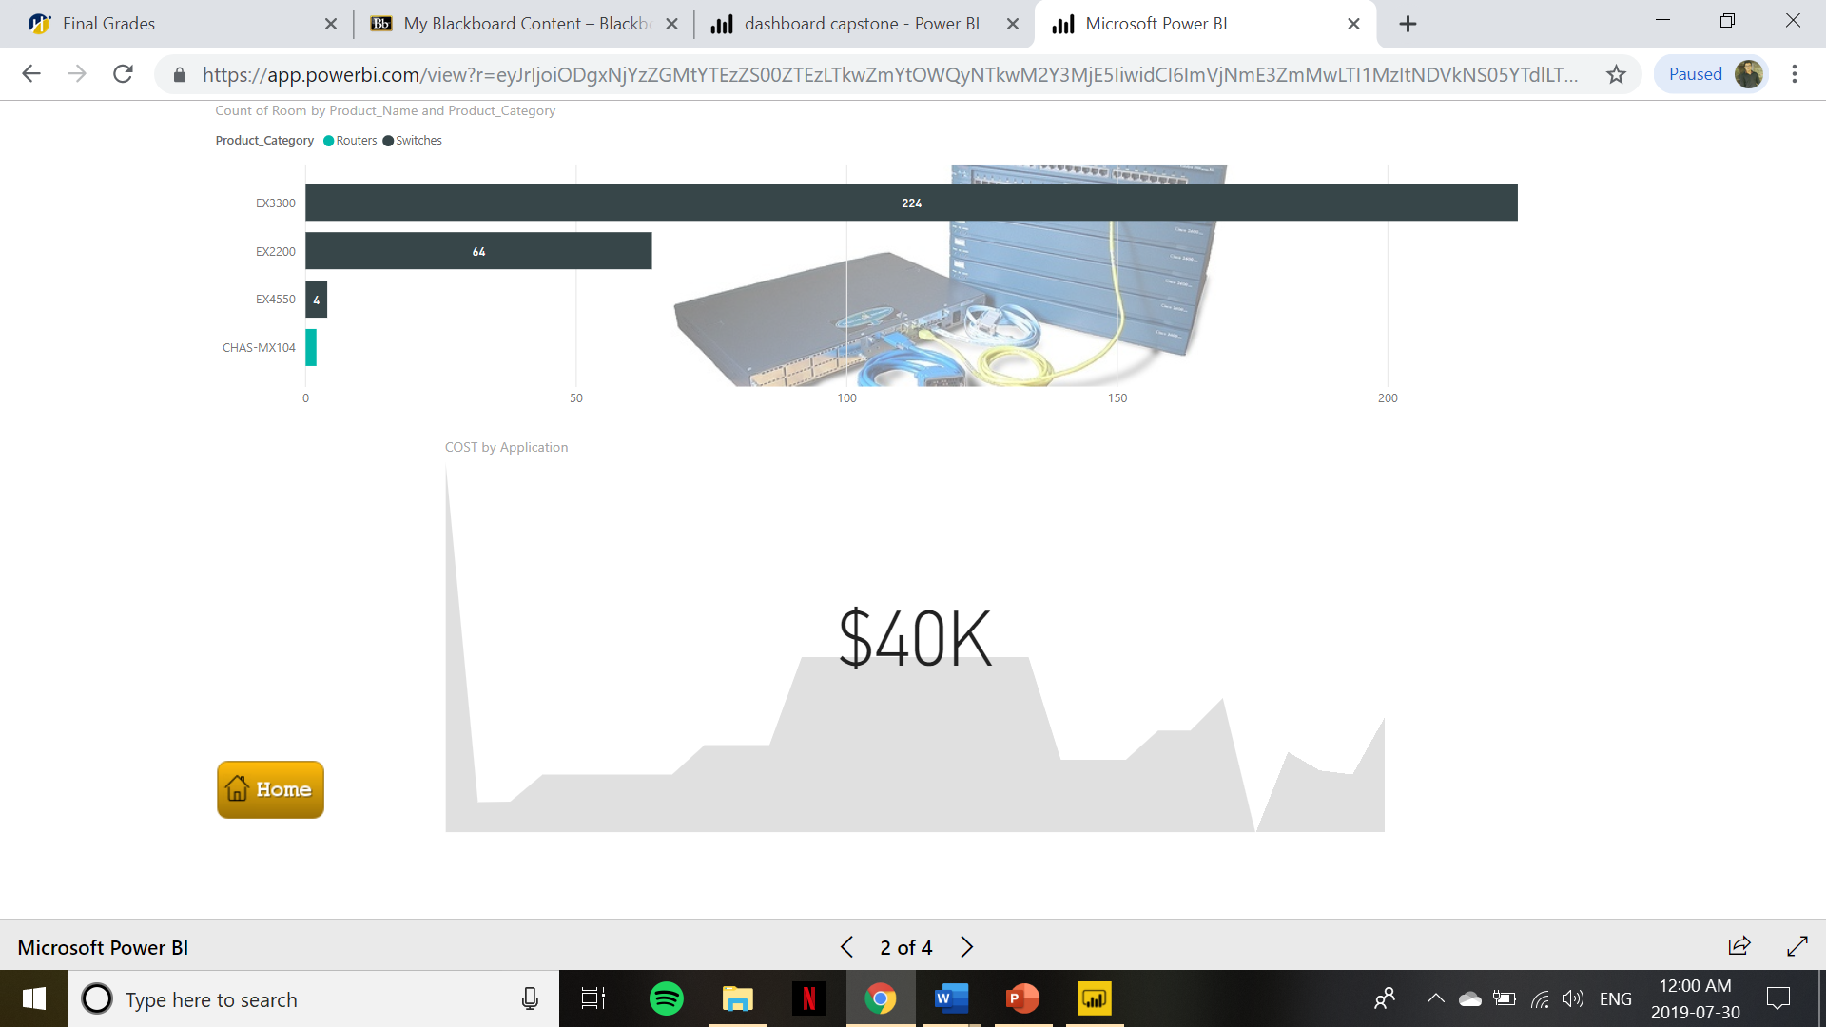

* With the implementation of Google maps we created a page through which we can see where are different server hardware are installed throughout various locations of college.

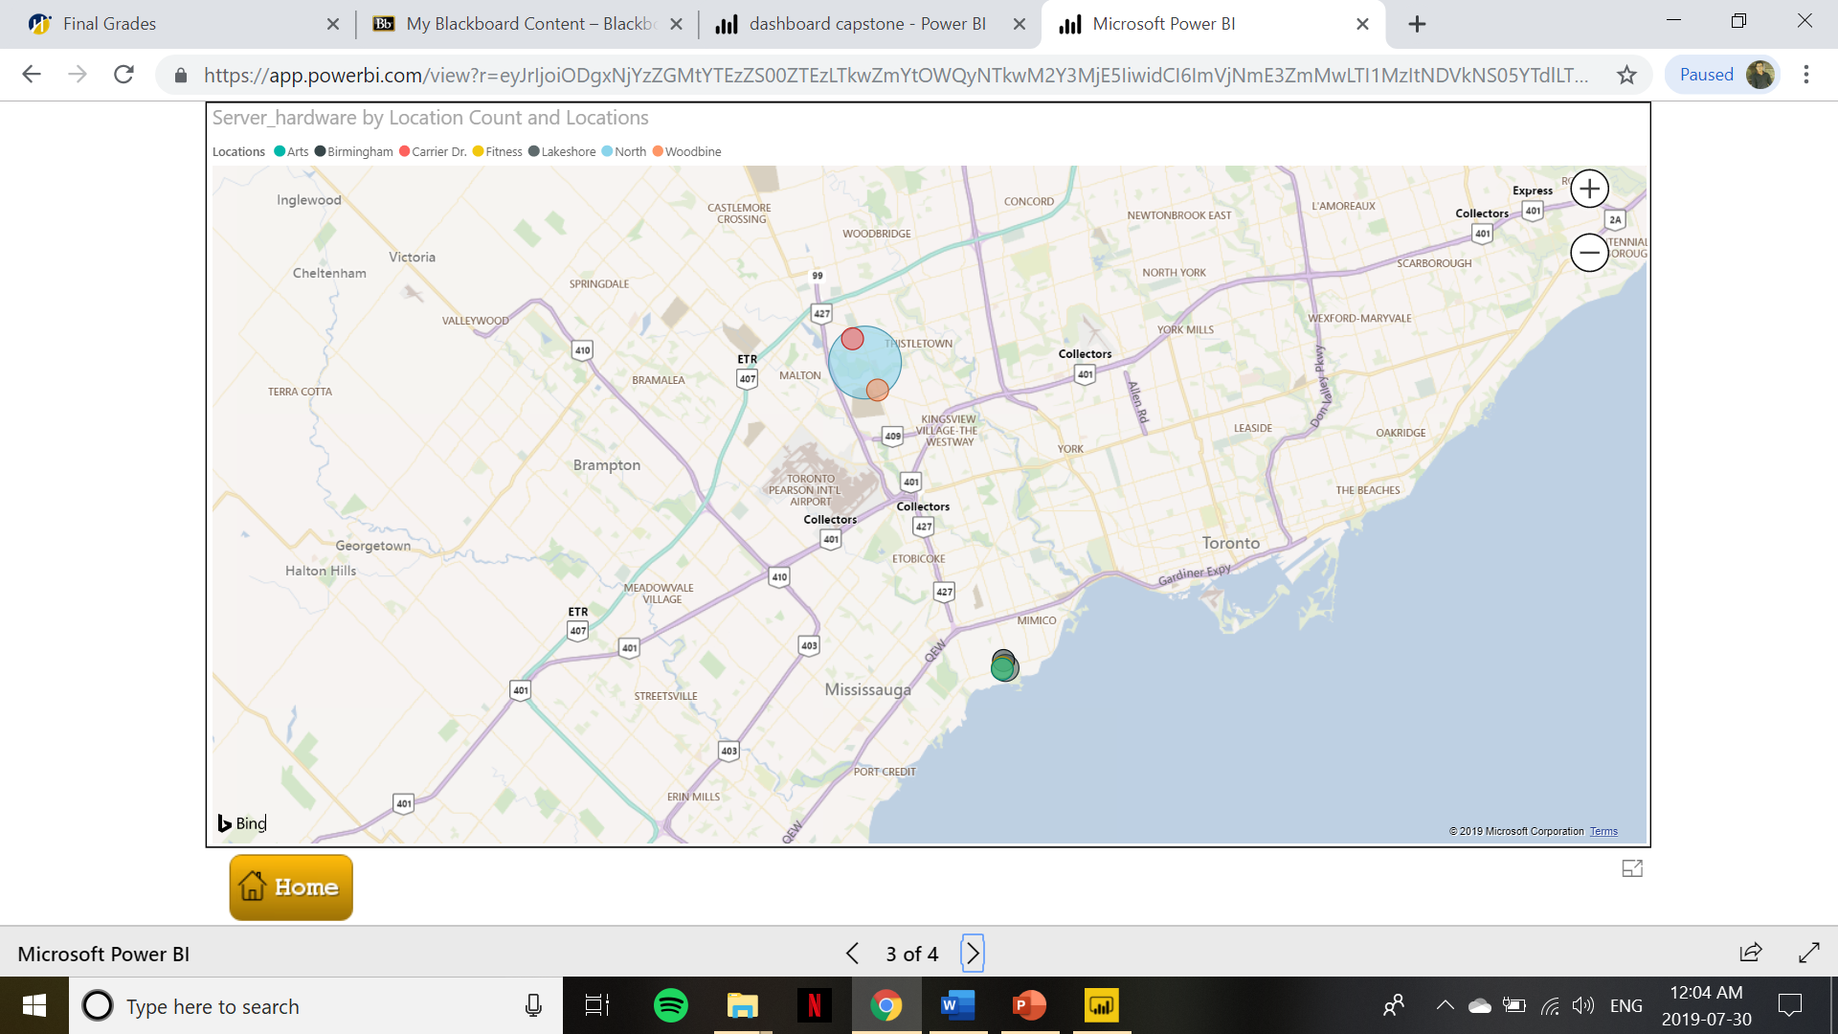

* Another tab gives the information of the server about it’s environment, tier it belongs to and it’s usage by creating a filter we can see the information of a specific server.

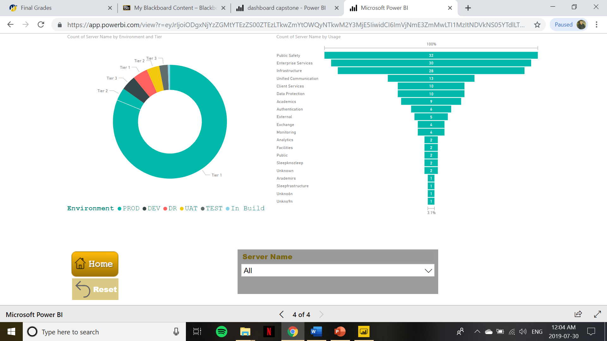

* By selecting Host- 112 in the bottom drop- down menu we can see its specific details.

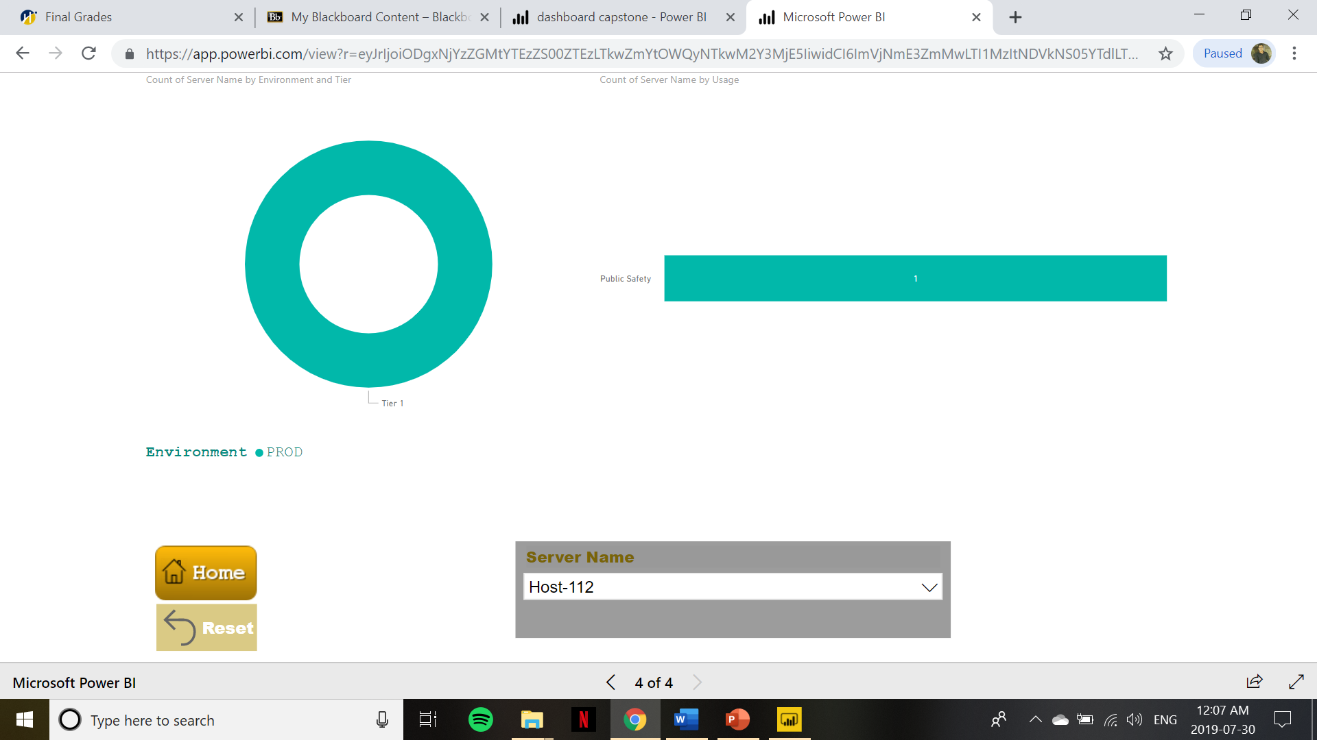

**FILTERING DATA**

To filter data, we queried some results that can only be achieved through SSMS. One of the examples was shown below where we get the server which is used maximum in every month.

So, that we can use it in our reports.

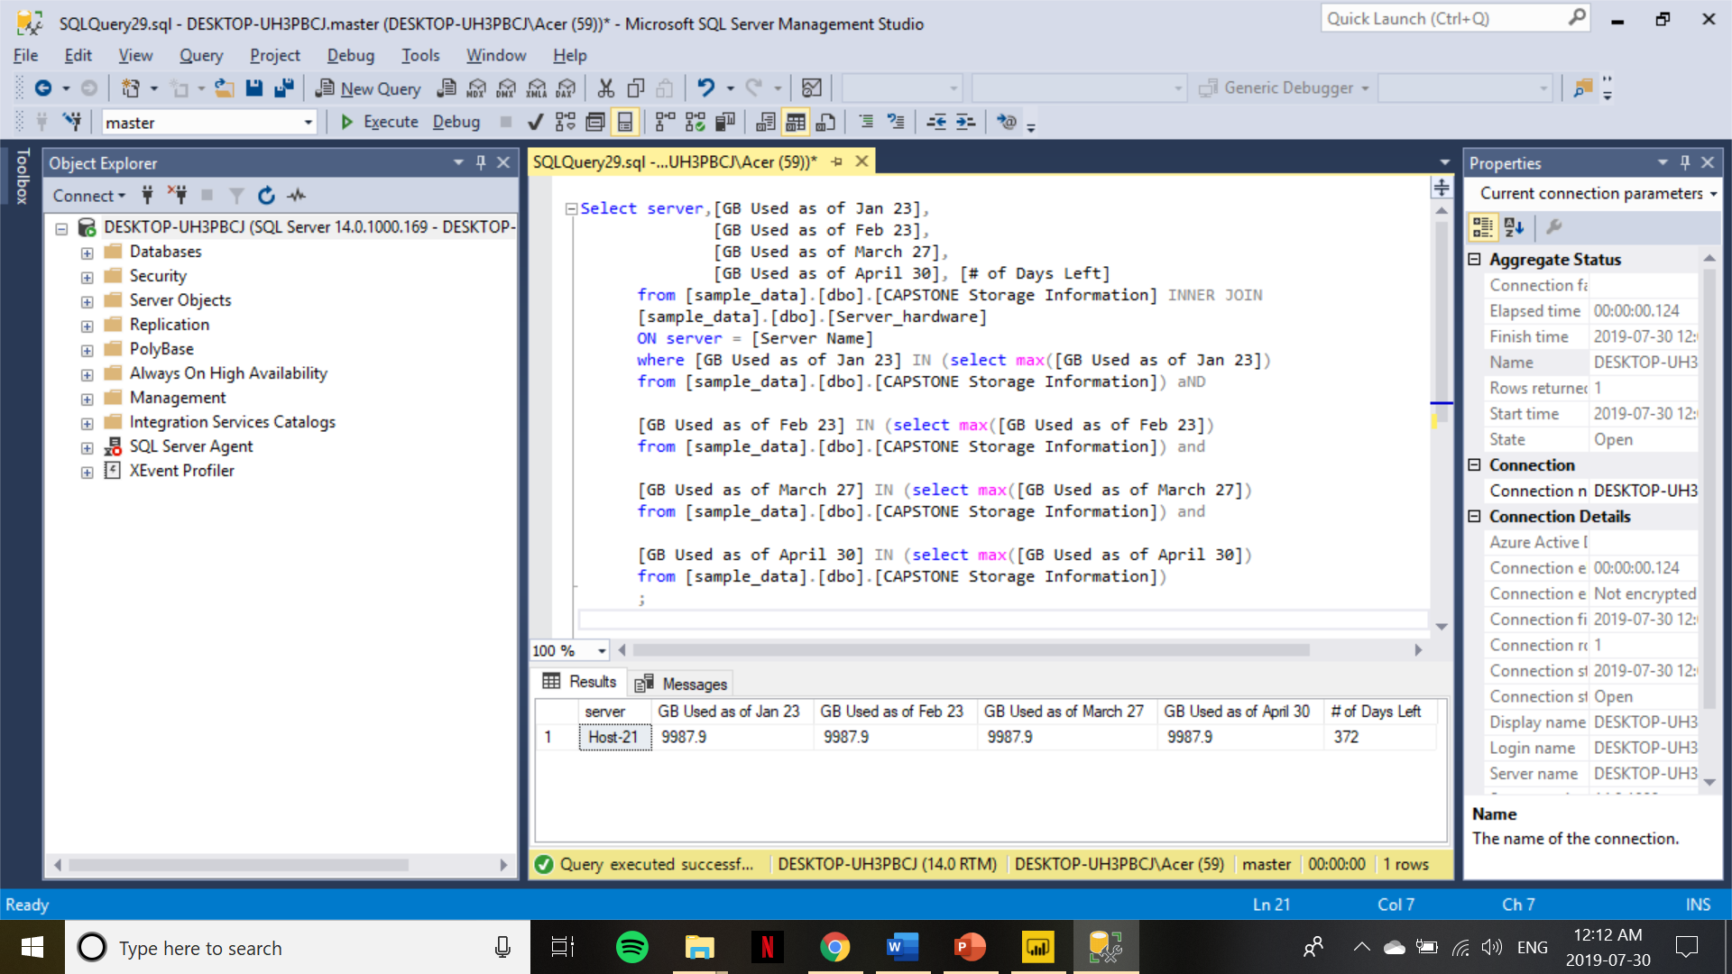

**REPORTS MOBILITY**

Just to give the whole project an extra edge we also deployed some of the reports on mobile phone which are currently usable on Power BI app. All the reports on the cellphone are dynamic and user can tap and see specific details on it as well.

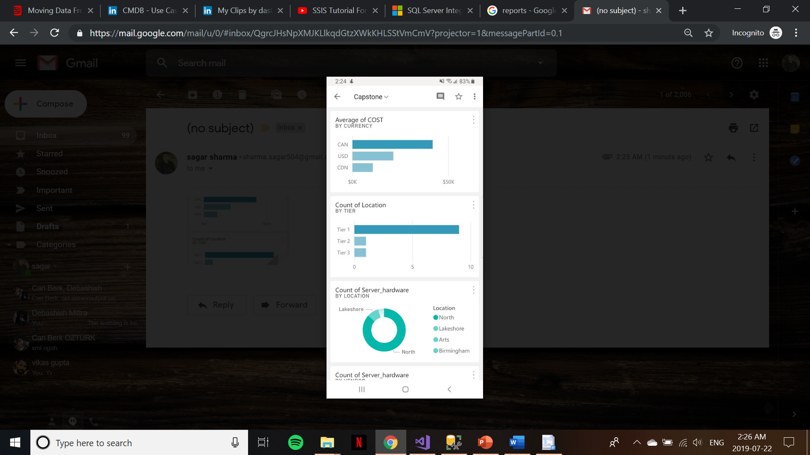

**Appendix: References**

For tools related consultation we used [https://docs.microsoft.com](https://docs.microsoft.com/) official microsoft’s website.

Also, several online resources were used.

To view dashboard on any device following link can be used.

<https://app.powerbi.com/view?r=eyJrIjoiODgxNjYzZGMtYTEzZS00ZTEzLTkwZmYtOWQyNTkwM2Y3MjE5IiwidCI6ImVjNmE3ZmMwLTI1MzItNDVkNS05YTdlLTY0NjM5NmVlNDI4NSIsImMiOjF9>